

SIMATS ENGINEERING

Saveetha Institute of Medical and Technical Sciences Chennai- 602105

Student Name: SR Kaarthika Reg. No:19241294
Course Code:CSA1706 Slot: B
Course Name: Artificial Intelligence
Course Faculty: Dr. Kalaiarasi
Project Title: Fake News Detection System

Module Photo graphs:
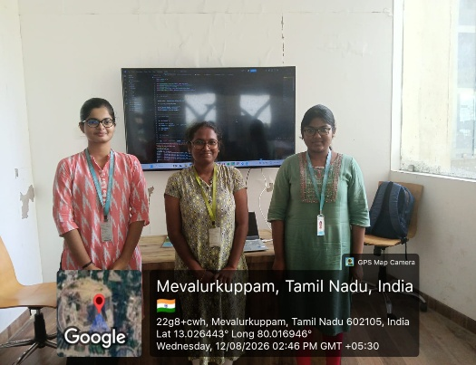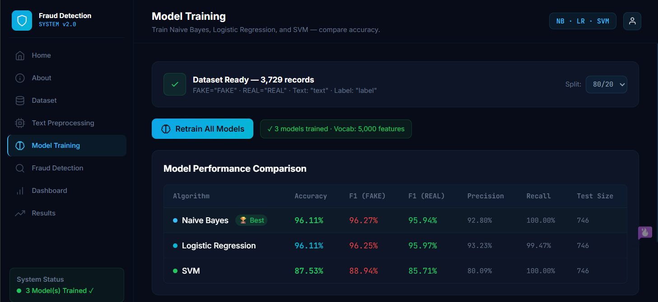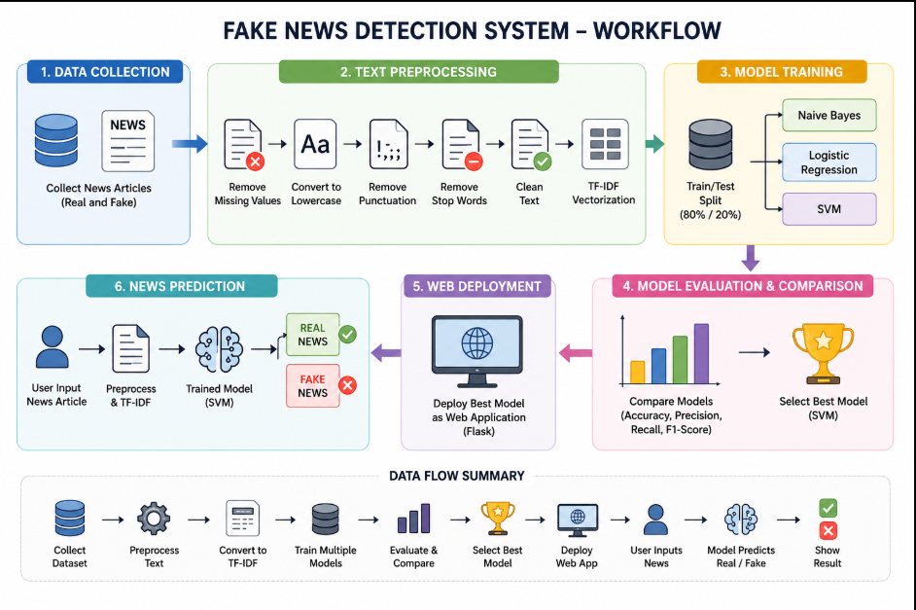

Project Description:
The NLP Model Training module is used to train the system to identify whether a news article is FAKE or REAL. First, the news text is cleaned by removing unwanted words, symbols, and punctuation. Then, TF-IDF converts the text into numerical values that the machine learning model can understand. These features are given to the Naive Bayes algorithm, which learns the patterns of fake and real news from the training dataset. The model is then tested using accuracy, precision, recall, and F1-score. Finally, the trained model is used to classify new news articles as FAKE or REAL.
.

Student Signature Guide Signature

